**Tutorial problems 3**

1. A rectangular metal $4m×2m$ plate has $x×x$ squares cut from its four

corners as illustrated and is then folded up to make an open box. Explain why do we need the restriction $0<x<1$? Find such dimensions of the box that the volume will be the largest.

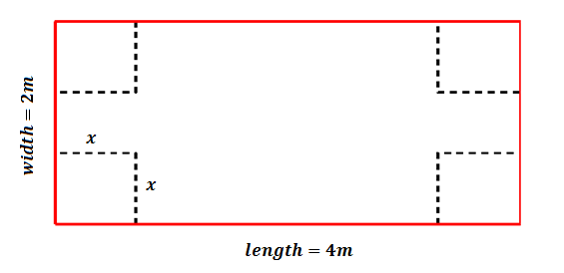

1. A cuboid container with a base length twice its width is to be made with $48 m^{2}$ of metal.

$a)$ Show that the height $h=\frac{8}{x}-\frac{2x}{3}$, where $x$ is the width of the base.

$b)$ Express the volume, $V$, in terms of $x$.

$c)$ Find the maximum volume.

1. A cylindrical container holds a volume of $1 litre (1000 {cm}^{3})$. Show that the surface area $A$ is given by $A=2πr^{2}+2000r^{-1}$. Find the dimensions so that the surface area is a minimum (minimizing the material used).
2. A rectangular plot of farmland is enclosed by $180 m$ of fencing material on three sides. The fourth side of the plot is bordered by a stone wall .Find the dimensions of the plot that enclose the maximum area. Find the maximum area.
3. Find the dimensions of an open box with a square base and surface area of 192 ${cm}^{2}$ that has a maximum volume.
4. Use implicit differentiation to find $\frac{dy}{dx}$:
$$a) 3y^{2}+x^{3}-\cos{y}=5e^{x}$$

$$b) 7x^{3}y^{5}-3e^{y}+2x^{4}-9=3\sin{x}$$

5. Write the equation of the tangent to the curve $x^{2}-y^{2}=9$ at the point $\left(5,4\right)$.
6. Write the equation of the normal to the curve $y^{2}=3x+1$ at the point $\left(1,-2\right)$.
7. Given the curve $x+y=x^{2}-2xy+y^{2}$.

$a)$ Find $\frac{dy}{dx}$

$b)$ Show that

$$1-\frac{dy}{dx}=\frac{2}{2x-2y+1}$$

$c)$ Show that

$$\frac{d^{2}y}{dx^{2}}={\left(1-\frac{dy}{dx}\right)}^{3}$$